**MEDICAL INVENTORY MANAGEMENT - CRM**

**Project Documentation - Naanmudhalvan Course**

**Team members :**

**Aparna MG**

**Ahla thesni**

**Anshida thesni**

**Ajith CR**

**PROJECT OVERVIEW**

The Medical Inventory Management System is developed on the Salesforce platform to efficiently manage medicines, equipment, and medical supplies in hospitals, clinics, and pharmacies. It automates stock tracking, generates reports, sends low-stock alerts, and reduces manual errors. By using Salesforce’s cloud-based CRM features, the project ensures scalability, security, and real-time access for healthcare staff.

**OBJECTIVES**

The primary objective of this CRM is to simplify and automate medical inventory management processes. Key goals include improving stock tracking, streamlining purchase order processing, enhancing supplier management, and providing real-time data through reports and dashboards. By implementing Salesforce-based automation, businesses gain better control over operations, reduce manual errors, and improve customer satisfaction.

**SALESFORCE COMPONENTS IMPLEMENTED**

1. **Custom Objects:**

The following custom objects were created to manage medical inventory data efficiently:  
• Product: Stores details of available medical products.  
• Supplier: Maintains supplier information and contact details.  
• Purchase Order: Tracks purchase requests, order status, and related products.  
• Inventory Transaction: Manages stock inflow and outflow.  
• Order Item: Stores product-specific details for each purchase order.

1. **Custom Fields:**

Added fields like Medicine Name, Batch No., Expiry Date, Quantity Available, Supplier Details. Various custom fields, formula fields, currency fields, and lookup relationships were created to manage data seamlessly. Examples include:  
• Formula Fields: Unit Price, Amount, Total Order Cost.  
• Lookup Relationships: Linking Purchase Orders with Suppliers and Products.  
• Picklist Fields: Used in Inventory Transactions to manage transaction types.

1. **Validation Rules:** Ensures correct data entry (e.g., expiry date > today, stock quantity ≥ 0).

Validation rules were implemented to ensure data integrity and accuracy:  
• Expected Delivery Date Validation: Ensures that the delivery date cannot be earlier than the order date.  
• Quantity Validation: Prevents negative or zero quantity values in order items.

1. **Process Builder / Flows:**

Automates re-order requests and updates stock when items are issued.

1. **Approval Processes:**

For purchase orders to be verified by Admin before stock addition.

1. **Profiles, Roles & Permission sets:**

Custom profiles and roles were created to manage user access:  
• Inventory Manager Profile: Full access to product and inventory management.  
• Purchase Manager Profile: Manages purchase orders and supplier data.  
• Permission Set: Grants additional permissions for specific fields and objects.

1. **Reports & Dashboards:**

Two custom reports were created:  
• Supplier-Based Purchase Orders Report: Displays purchase details grouped by suppliers.  
• Complete Purchase Details Report: Provides a summary of all purchase orders and their statuses.  
Additionally, a custom dashboard was designed to provide a visual representation of purchase orders and inventory status.

1. **Sharing & Security Settings:**

Role-based access to secure sensitive medical inventory data.

Admins have full access, pharmacists have controlled access to medicines and sales records, while staff have limited access as per their responsibilities.

1. **Apex Triggers:**

Apex Triggers were developed to apply custom logic for inventory updates.

Custom logic to automatically update inventory when medicines are issued.

For example, whenever a sales order is confirmed, the corresponding medicine stock is automatically reduced. This ensures real-time and error-free stock management.

1. **Salesforce Mobile App Integration:**

Enables staff to check inventory from mobile devices.

**Screenshots:**

Inserted Salesforce Setup and Configuration Screenshots of each feature here.

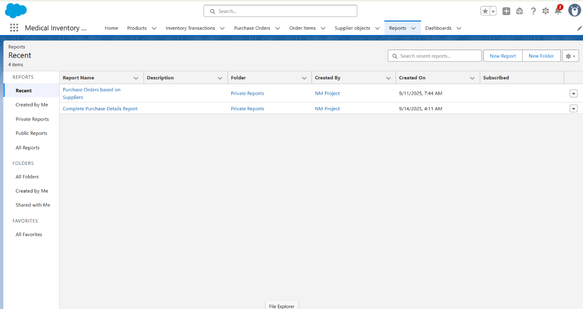

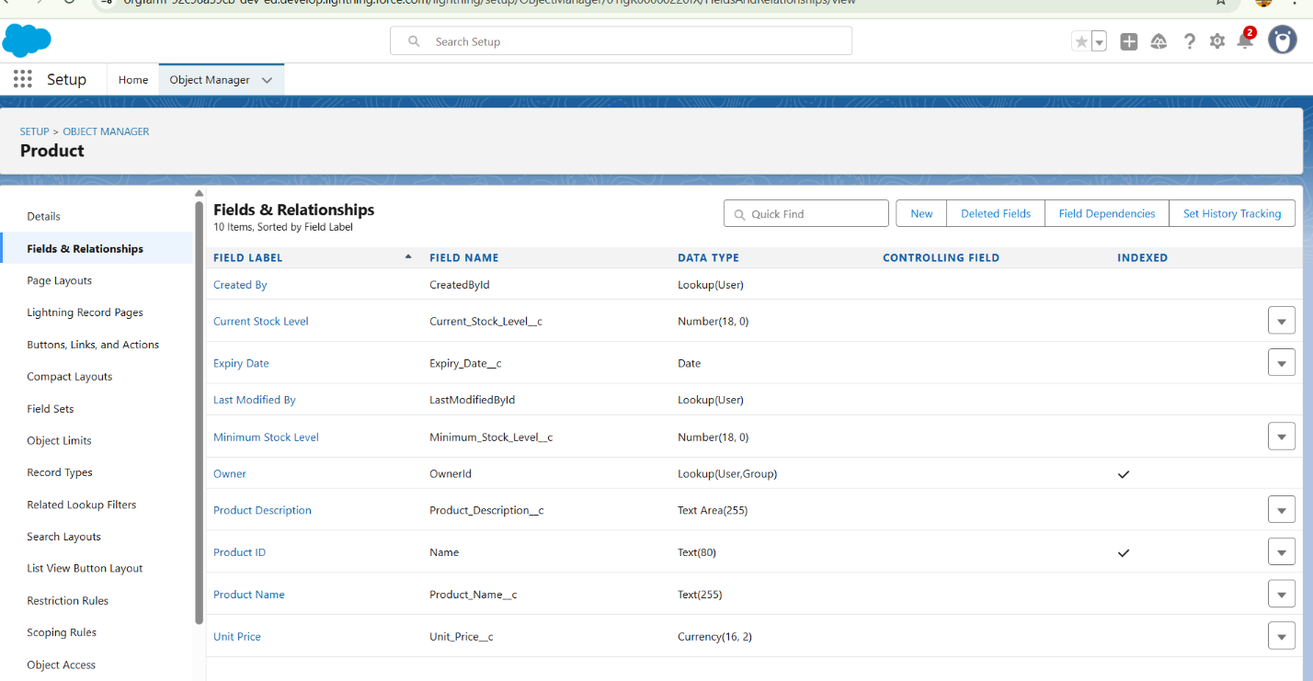

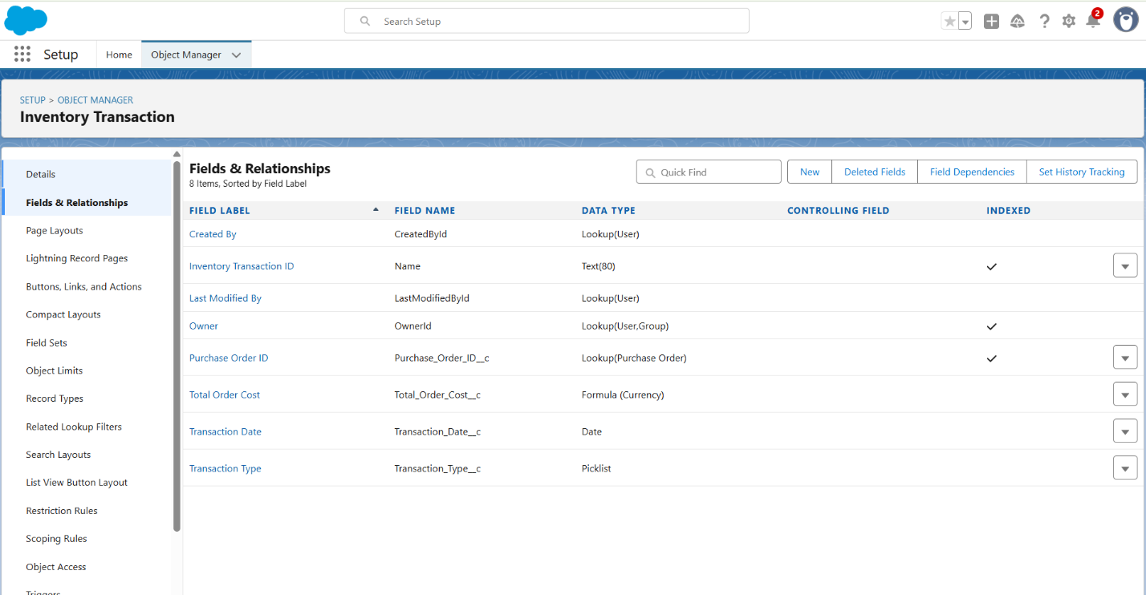

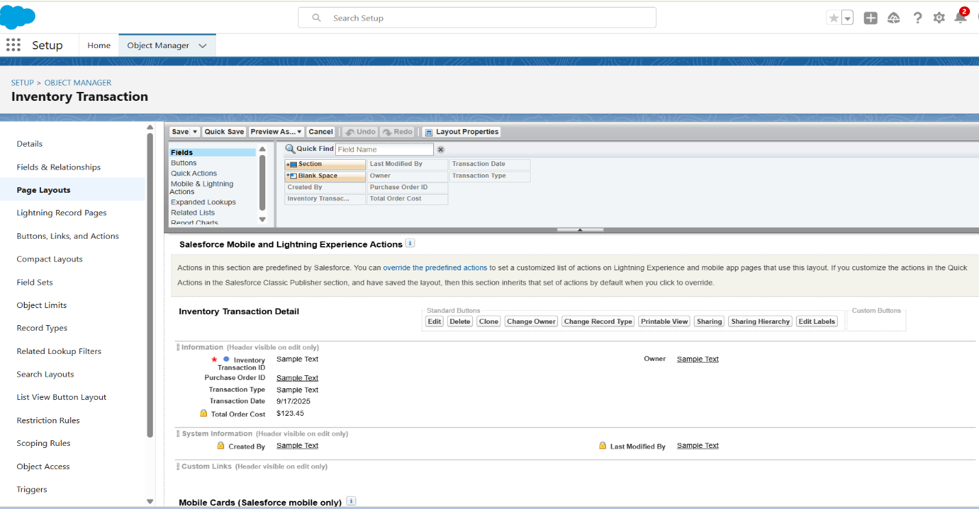

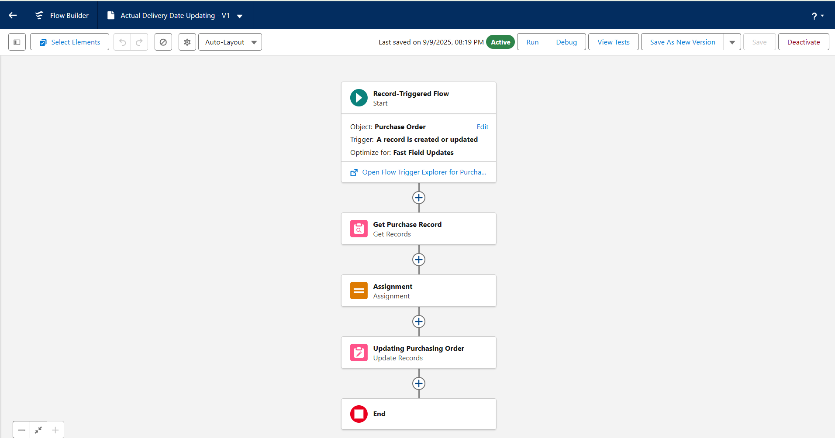

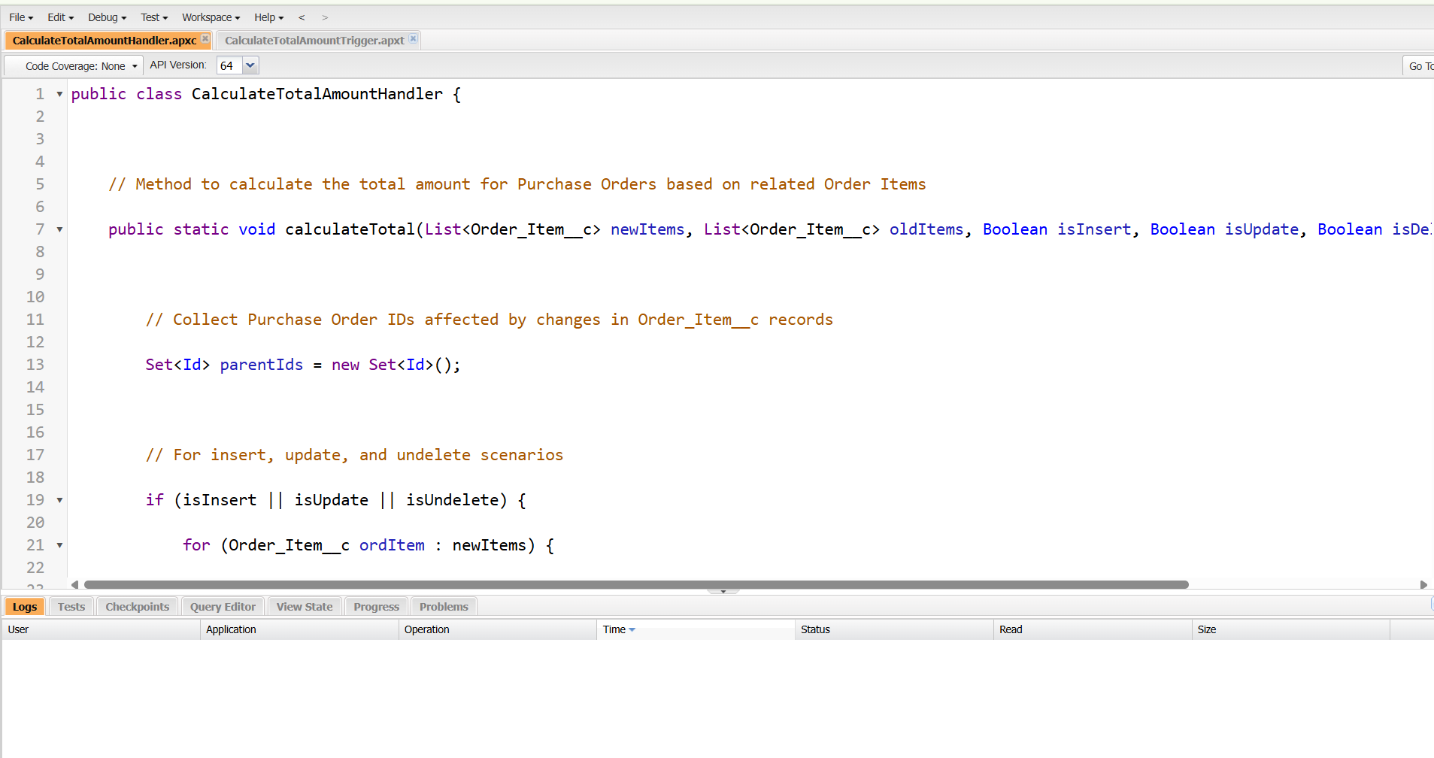

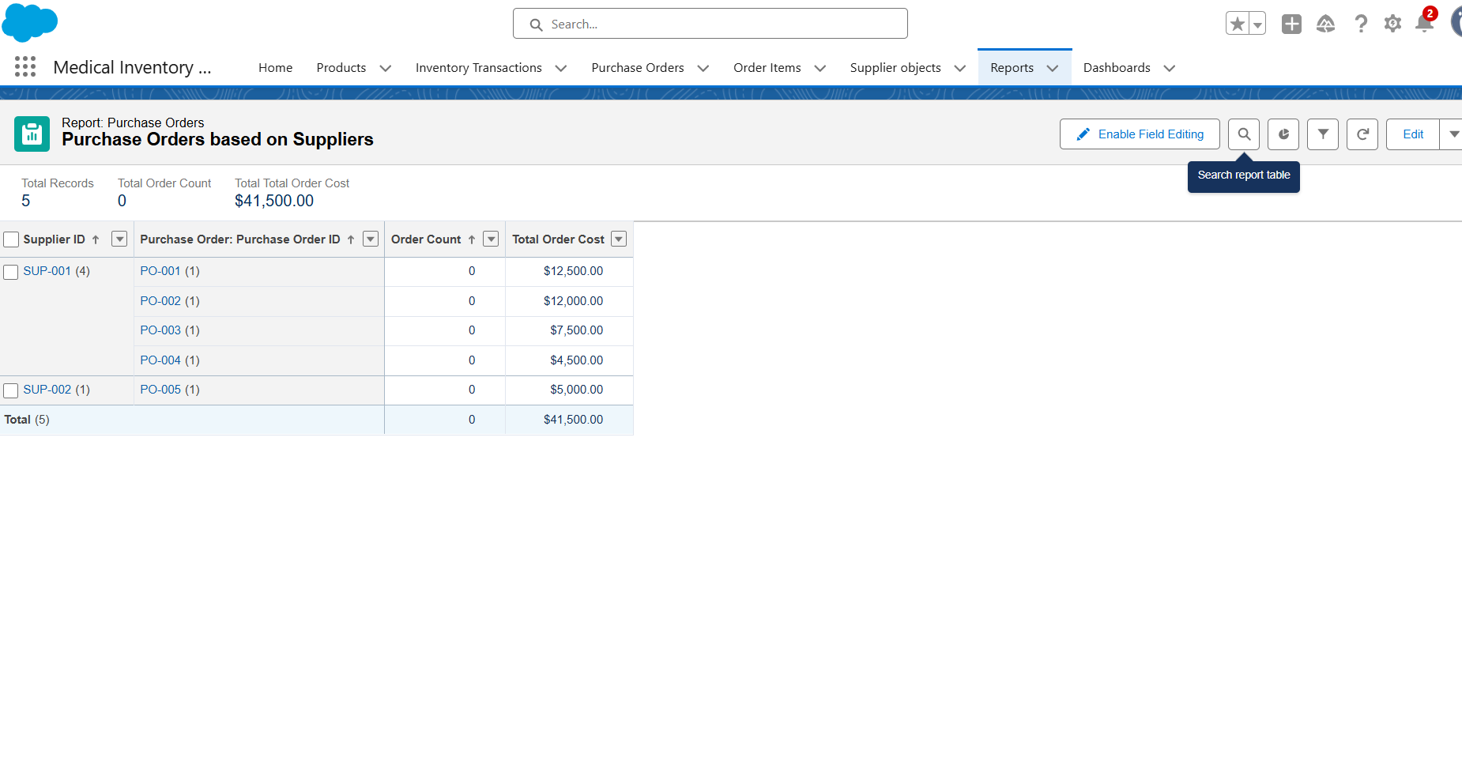

**TESTING APPROACH:**

Testing was performed for all configured components to ensure smooth functionality:  
**• Flows:** Tested using sample purchase orders to confirm automatic updates.  
**• Reports & Dashboards:** Verified accurate data grouping and calculations.  
**• Triggers:** Tested positive and negative scenarios for amount calculatins.  
**• Validation Rules:** Ensured invalid data entries are restricted.

**FUTURE ENHANCEMENT :**

Possible Future enhancement include:

* **Barcode/QR code scanning** for faster stock entry and tracking.
* **AI-powered demand forecasting** for medicines and supplies.
* **Integration with Supplier ERP systems** for automated purchase orders.
* **Mobile application** for remote access and real-time notifications.
* **Cloud integration with IoT devices** to track medicine storage conditions (temperature, expiry).

**CONCLUSION**

The Medical Inventory Management System built on Salesforce provides an efficient, secure, and automated way to manage hospital inventory. It minimizes manual work, reduces errors, and ensures timely availability of medical supplies. With its flexible Salesforce components and future AI/IoT integration possibilities, the system is scalable and adaptable for modern healthcare needs.